Dynamic Analysis
Instrument Element Procedure

Revision
Version 2
10/9/25 10:43 AM

SME
Charles Wilson

Abstract
This document describes the procedure used to perform the instrument element activity described in the AVCDL ^{[1]} secondary document Dynamic Analysis Report ^{[2]}.

Group / Owner
Security / Security Architect

Motivation
This document is motivated by the need to have runtime-specific, cybersecurity-related feedback in the development of software for use within safety-critical, cyber-physical systems.
Note: Within the context of this document, the terms security and cybersecurity are used interchangeably. It is presumed that the term security is being used in reference to cybersecurity and not physical security.

License
This work was created by Torc Robotics and is licensed under the Creative Commons Attribution-Share Alike (CC BY-SA-4.0) License.
https://creativecommons.org/licenses/by/4.0/legalcode

Audience
The audience of this document is the cybersecurity practitioner who will be conducting cybersecurity-specific dynamic analysis.

Completeness of Output
Since dynamic analysis is an as-is analysis, it is critical to ensure that the information gathered is as accurate and complete as possible. As with any cybersecurity assessment, it is not the place of the cybersecurity SME to make assumptions on the part of engineering. All information should be sourced from and confirmed by the owner of the element under consideration.

Disposition of Output
This activity does not produce documentation as an output.

Entry Criteria
This document assumes that the reader understands the purpose of cybersecurity-specific dynamic analysis. Further, that the reader has read and understood the AVCDL Dynamic Analysis Report ^{[2]} secondary document.

Prerequisites – Security SME

Qualifications
It is required that the threat modeling SME is both a qualified and trained security architect (shown above on title page as Owner) as defined by the NIST NCWF role SP-ARC-002 and detailed in section 12.7 Security Architect of the AVCDL primary document.

Knowledge
It is required that the cybersecurity SME understands the purpose of cybersecurity-specific dynamic analysis.

Background Information
It is required that the cybersecurity SME has read and understands the AVCDL Dynamic Analysis Report secondary document. Additionally, that the cybersecurity SME has taken training relevant to this activity.

Prerequisites – DevOps SME

Qualifications
It is required that the DevOps SME is both a qualified and trained DevOps SME with expertise in the build system used for the element under consideration in the context of the dynamic analysis tool being employed.
Note: The specific qualifications and training of DevOps SMEs necessary to assert expertise in providing accurate information regarding the build system used for the element under consideration is outside the scope of this document.
Note: The DevOps group is responsible for determining and making available the appropriate SME for the modifications to build system needed for the tool under consideration.

Knowledge
It is required that the DevOps SME have expertise in the build system used for the element under consideration in the context of the dynamic analysis tool being employed.

Prerequisites – Input Materials
It is required that the cybersecurity SME acquire all relevant documentation related to the tool under consideration necessary to complete the procedure.

Instrument Element Activity
The workflow diagram for the instrument element activity of the Dynamic Analysis process is shown below.
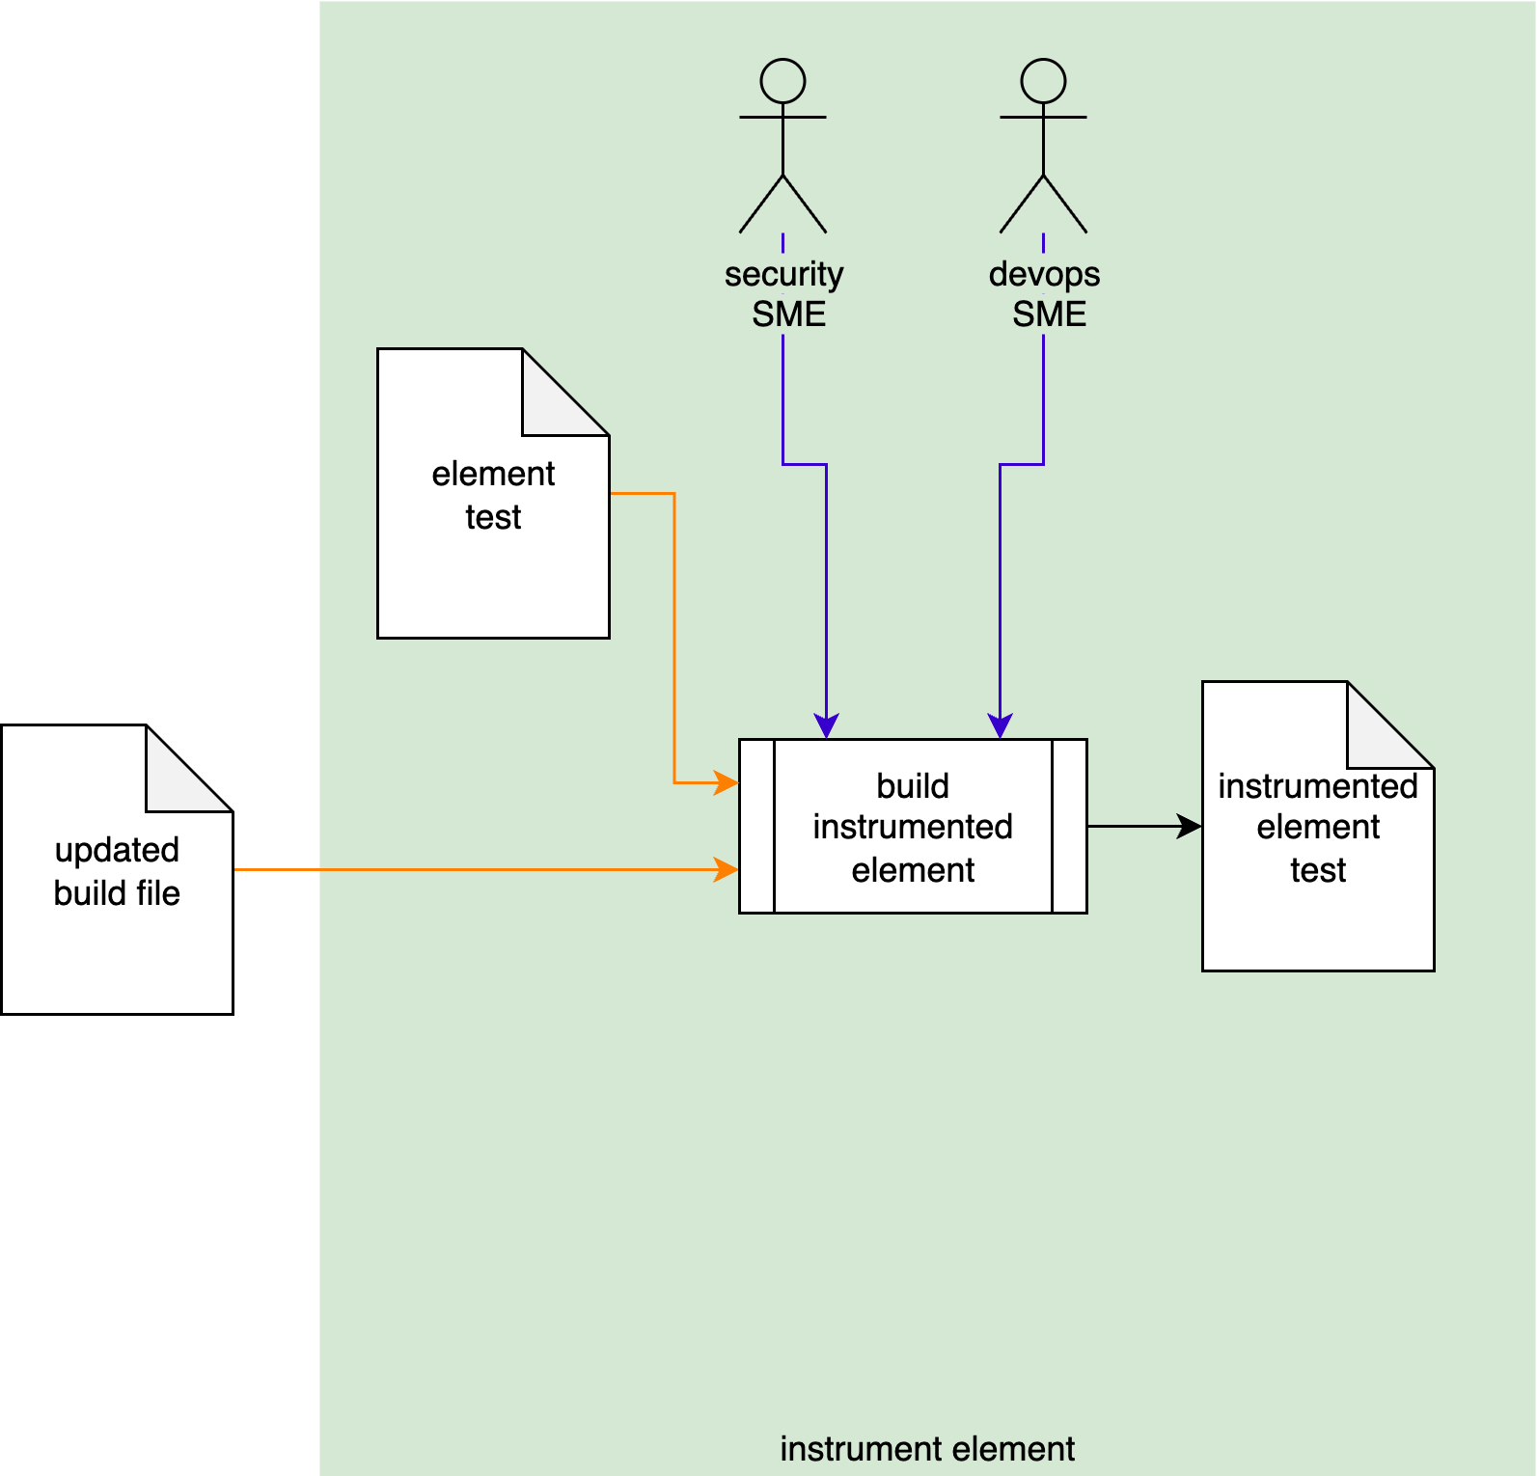
Using the Updated Build File created in the Dynamic Analysis - Establish Settings activity ^{[3]}, the Security and DevOps SMEs will take the Element Test and make adjustments to allow for use in a dynamic analysis context. An Instrumented Element Test will be produced.
Note: In some cases, the Security SME may perform this activity alone or the activity may even be fully automated.
Note: The scope of the Element Test may be as small as a single file, or as large as the entire project.

Methodology
Because of the diversity of individual dynamic analysis tool, the implementation of this activity is deferred to the documentation provided by the chosen dynamic analysis tool.

Considerations
Since dynamic analysis is a run time activity typically utilized via a test suite, there are several things that need to be taken into consideration.

Termination on Error
Most dynamic analysis tools default to a termination-on-failure behavior. It is therefore important to adjust the test suite to take this into consideration.

Footprint (Code / Memory)
The instrumentation of code for dynamic analysis purposes may incur non-trivial executable size and memory footprint impacts. These may impact both size and execution timing.

Cybersecurity Side-effects
An important consideration is that because dynamic analysis require intrusive access to data structures within the code, there may be a significant impact on other cybersecurity-related tooling. These should probably be disabled in order to not trigger false positives in those tools.

Exit Criteria
This procedure is considered complete once the Instrumented Element Test has been created.

References
- AVCDL (AVCDL primary document)
- Dynamic Analysis Report (AVCDL secondary document)
- Dynamic Analysis Element Selection Procedure (AVCDL tertiary document)

